**Final Report**

**Customer Churn Prediction**

**Marripally Ravikumar**

**PGP – DSBA Online**

**May 2021**

**Date: 05/06/202****2**

**Table of contents**

|  |  |
| --- | --- |
| **Content** | **Page No.** |
| Q1. Introduction | 4 |
| Q2. EDA and Business Implication | 7 |
| Q3. Data Cleaning and Pre-processing | 20 |
| Q4. Model building | 26 |
| Q5. Model validation | 29 |
| Q6. Final interpretation / recommendation | 32 |

**List of Figures**

|  |  |
| --- | --- |
| **Figure** | **Page No.** |
| Figure 1. Histogram and Box Plot of Continuous Numerical Features. | 10 |
| Figure 2. Count Plots for Categorical Features. | 12 |
| Figure 3. Count Plot of Categorical Features with Churn as Hue. | 14 |
| Figure 4. Box Plot of Numerical Features with Churn as Hue. | 16 |
| Figure 5. Pair Plot. | 17 |
| Figure 6. Heat Map with Correlation Coefficients. | 18 |
| Figure 7. Churn across City Tier and Complain in last year | 18 |
| Figure 8. Churn across Account Segment and Complain in last year | 19 |
| Figure 9. Churn across Account Segment and City Tier in last year | 19 |
| Figure 10. Churn across Day since cc connects and Tenure. | 20 |
| Figure 11. Performance Metrics of all Models with Tuned Hyperparameters for the Test Dataset. | 32 |
| Figure 12. Performance Metrics of all Models with Tuned Hyperparameters and threshold of 0.4 for the Test Dataset. | 33 |
| Figure 13. Features Importance of Top 10 Features in Extreme Gradient Boosting Model. | 34 |

**List of Tables**

|  |  |
| --- | --- |
| **Table** | **Page No.** |
| Table 1. Sample of the Dataset. | 4 |
| Table 2. Data Types of All Features in the Dataset before and after cleaning. | 6 |
| Table 3. Description of Numerical Features in Dataset. | 7 |
| Table 4. Description of Categorical Features in the Dataset. | 7 |
| Table 5. Skewness and Kurtosis of Numerical Features. | 10 |
| Table 6. Percentage of Null Values in Each Feature before and after Treating. | 21 |
| Table 7. Percentage of Outliers in Each Feature before and after Treating. | 22 |
| Table 8. Sample of the Train and Test Datasets for Tree-based Models. | 24 |
| Table 9. Mean and Standard Deviation of All Numeric Features. | 25 |
| Table 10. Samples of Train and Test Datasets after Scaling (for weight-based models). | 25 |
| Table 11. P-Values in chi-square test for each categorical variable. | 26 |
| Table 12. Default Hyperparameters of All Models. | 28 |
| Table 13. Performance Metrics of Models with Default Hyperparameters. | 29 |
| Table 14. Tuned Hyperparameters of All Models. | 30 |
| Table 15. Performance Metrics of Models with Tuned Hyperparameters. | 31 |
| Table 16. Performance Metrics of all Models with Tuned Hyperparameters for the Test Dataset. | 31 |
| Table 17. Performance Metrics of all Models with a threshold of 0.4 for the Test Dataset. | 32 |

**Q1. Introduction**

**Problem statement**

A DTH provider is facing a lot of competition in the current market and it has become a challenge to retain the existing customers in the current situation. Hence, the company wants to develop a model through which they can do churn prediction of the accounts and provide segmented offers to the potential churners. In this company, account churn is a major thing because one account can have multiple customers. hence by losing one account the company might be losing more than one customer.

**Need for the study**

* Account churning is a major problem in the DTH industry.
* Retaining existing customers has become a big challenge.
* Churn rate of the given DTH company is 16.8% which is higher than the mean churn rate (10%) in the DTH industry.
* Cost of acquiring a new customer is almost 5 to 6 times higher than retaining the customer. Hence, it is better to invest in retaining new customers than attracting new customers.
* Every company has to focus to reduce the churn rate to improve profits.
* The main goal of this project is to help the DTH company by developing a model to predict churn by using Machine Learning Algorithms.
* Then, we need to suggest customer-specific offers based on the revenue generated by them.

**Q2. EDA and Business Implication**

**Visual and Non-Visual Understanding of the Data**

**Sample of the Dataset**

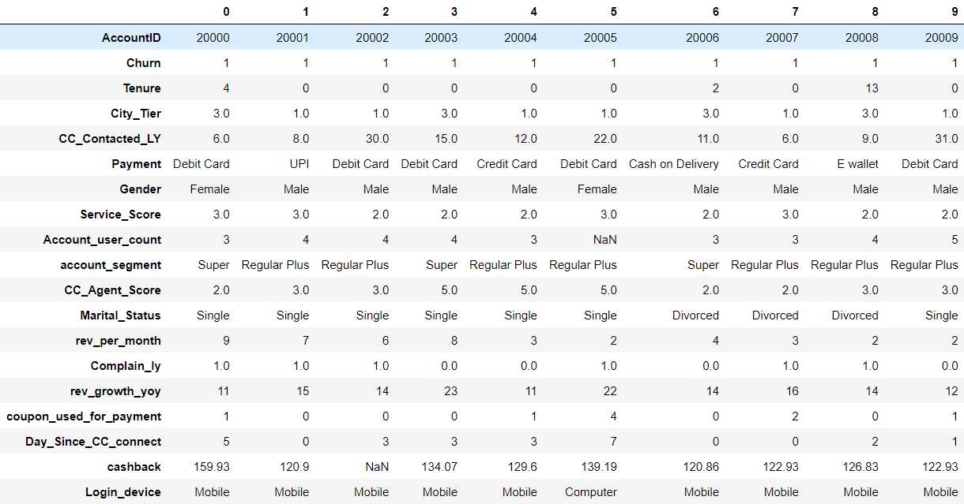

Table 1. Sample of the Dataset.

**Insights**

1. There are 18 features (columns) with 11260 observations (rows) in the dataset.
2. The dataset has both numerical variables and categorical variables.
3. The **target variable** in this dataset is **Churn**.
4. There are no duplicate observations in the dataset.

**Let us Understand Every Feature in detailed**

| **Variable** | **Description** |
| --- | --- |
| AccountID | Account unique identification number. |
| Churn | Account churn flag. This is the target variable to be predicted. |
| Tenure | Tenure of account |
| City_Tier | Tier of primary customer’s city |
| CC_Contacted_L12m | How many times all the customers of the account have contacted customer care in the last 12 months |
| Payment | Preferred Payment mode of the customers in the account |
| Gender | Gender of the primary customer of the account |
| Service_Score | Satisfaction score given by customers of the account on service provided by the company |
| Account_user_count | Number of customers tagged with this account |
| account segment | Account segmentation on the basis of spend |
| CC_Agent_Score | Satisfaction score given by customers of the account on customer care service provided by the company |
| Marital Status | Marital status of the primary customer of the account |
| rev_per_month | Monthly average revenue generated by account in last 12 months |
| Complain_l12m | Any complaints have been raised by account in the last 12 months |
| rev_growth_yoy | revenue growth percentage of the account (last 12 months vs last 24 to 13 months) |
| coupon_used_l12m | How many times customers have used coupons to do the payment in the last 12 months |
| Day_Since_CC_connect | Number of days since no customers in the account have contacted the customer care |
| cashback_l12m | Monthly average cashback generated by account in the last 12 months |
| Login device | Preferred login device of the customers in the account |

**Basic Information of the Dataset**

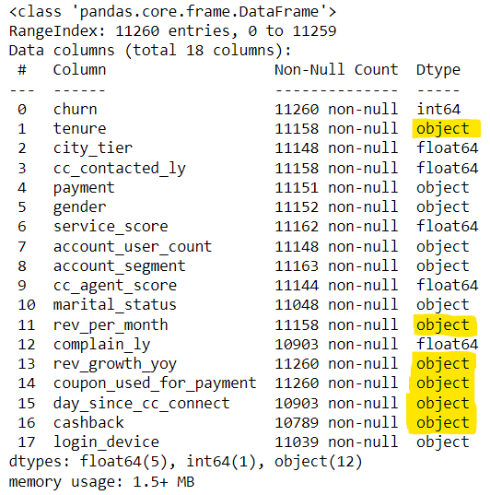 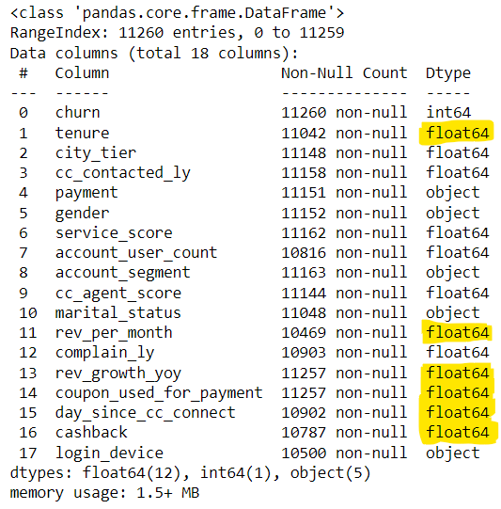

Table 2. Data Types of All Features in the Dataset before and after cleaning.

* From the table, we can notice that features like **tenure, rev_per_month, rev_growth_yoy, coupon_used_for_payment, day_since_cc_connect and cashback** are expected to have **numerical data** types but they have an **object data** type.
* We need to find out why these features have object data types before proceeding to further analysis.

**Anomalies in the dataset**

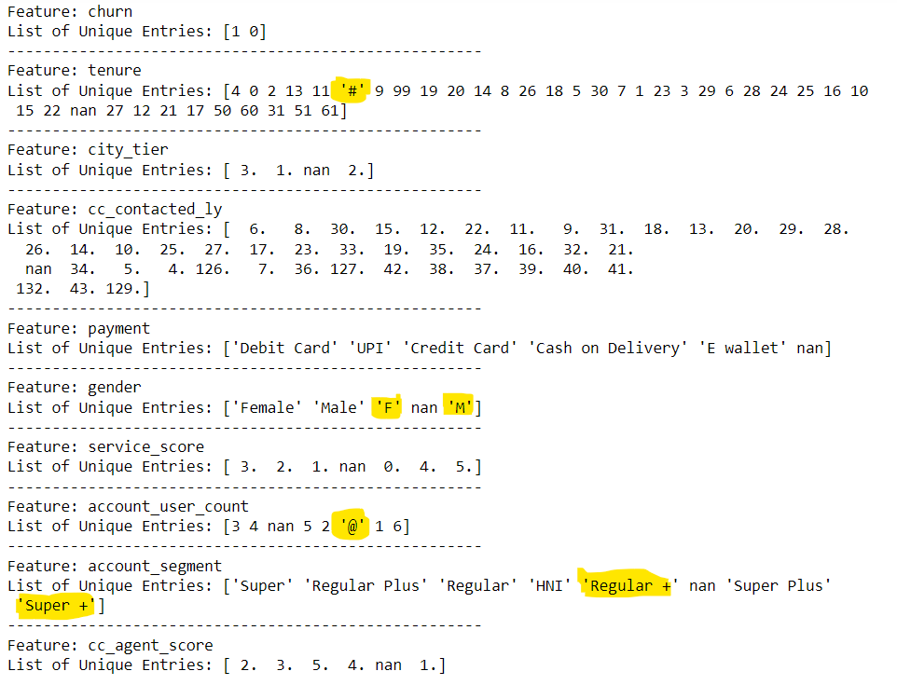

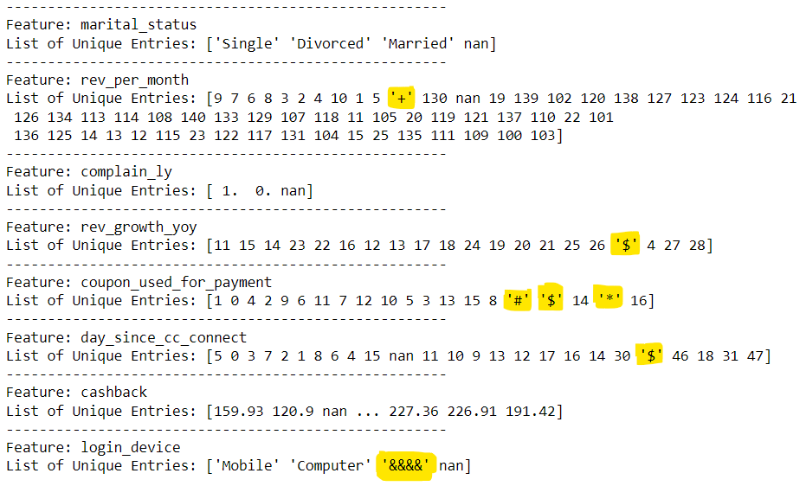

* Few columns having their entries as **special symbols like #, @, +, $, *, &.** This might be the reason for identifying numerical data types as an object.
* Let us **replace these special symbols with null values** and later null values will be imputed with an appropriate method.
* Few features have duplicate sublevels like Gender having ‘Male’ and ‘M’.
* We need to clean these anomalies before proceeding to further analysis.

**Description of the Dataset**



Table 3. Description of Numerical Features in Dataset.



Table 4. Description of Categorical Features in the Dataset.

**Univariate Analysis**

**Histogram and Box Plots for Continuous Variables**

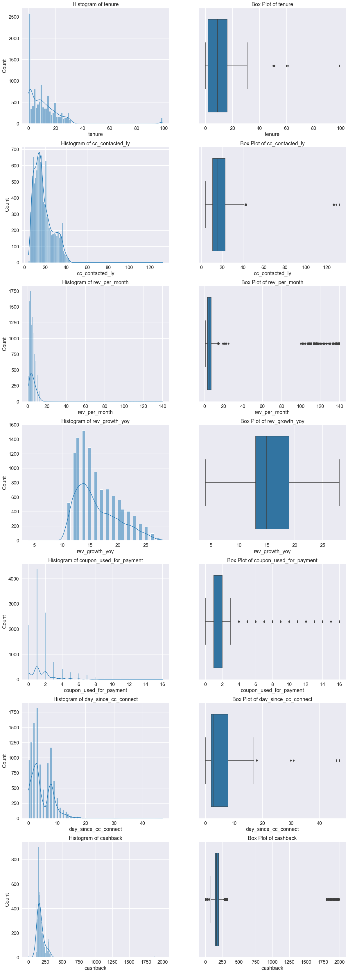

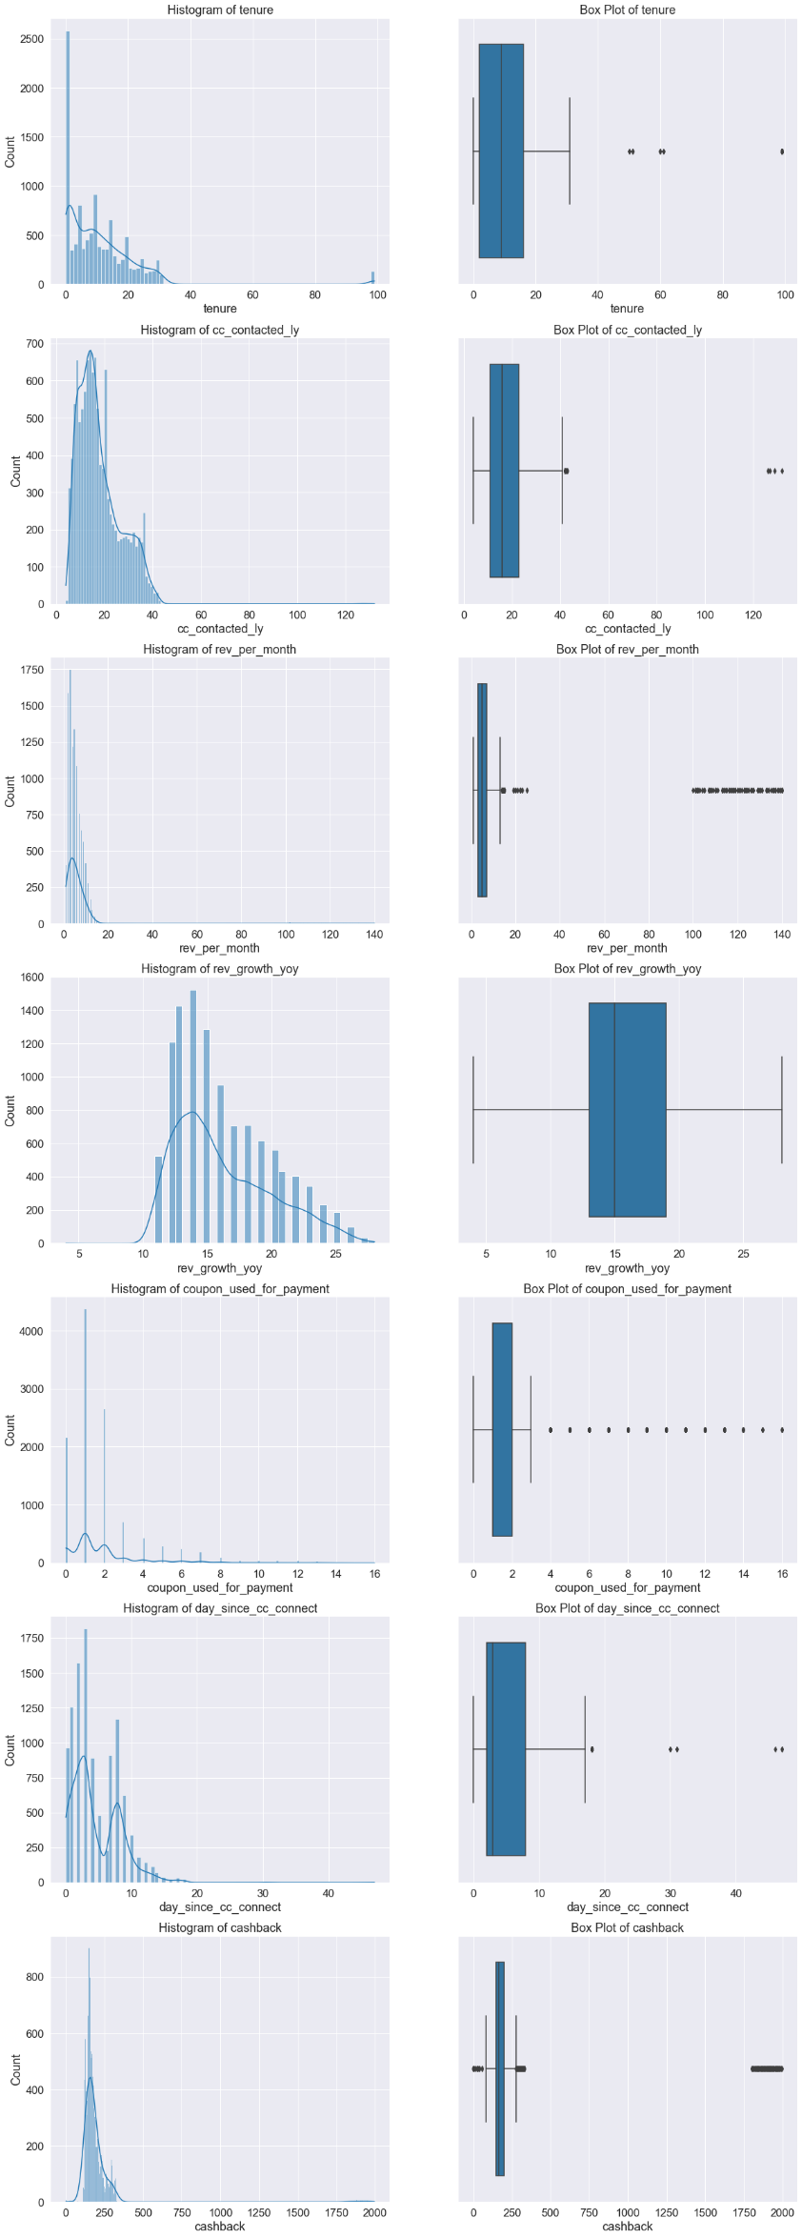



Figure 1. Histogram and Box Plot of Continuous Numerical Features.

**Skewness & Kurtosis for Numerical Continuous Variables**

* Skewness is a measure of lack of symmetry in distribution.
* Kurtosis is a measure of whether the data are heavy-tailed or light-tailed relative to a normal distribution.

**Insights**

From the above plots and tables, we can conclude the below points,

1. All features are having **right-skewed** distribution.
2. Rev_growth_yoy has negative kurtosis (-0.22). All remaining features have **positive kurtosis** values.

|  |  |  |
| --- | --- | --- |
| **Feature** | **Skewness** | **Kurtosis** |
| Tenure | 3.90 | 23.37 |
| CC contacted LY | 1.42 | 8.23 |
| Rev per month | 9.09 | 86.96 |
| Rev growth YoY | 0.75 | -0.22 |
| Coupons used for payment | 2.58 | 9.10 |
| Day since cc connect | 1.27 | 5.33 |
| Cashback | 8.77 | 81.11 |

Table 5. Skewness and Kurtosis of Numerical Features.

**Count Plots for Categorical Features**

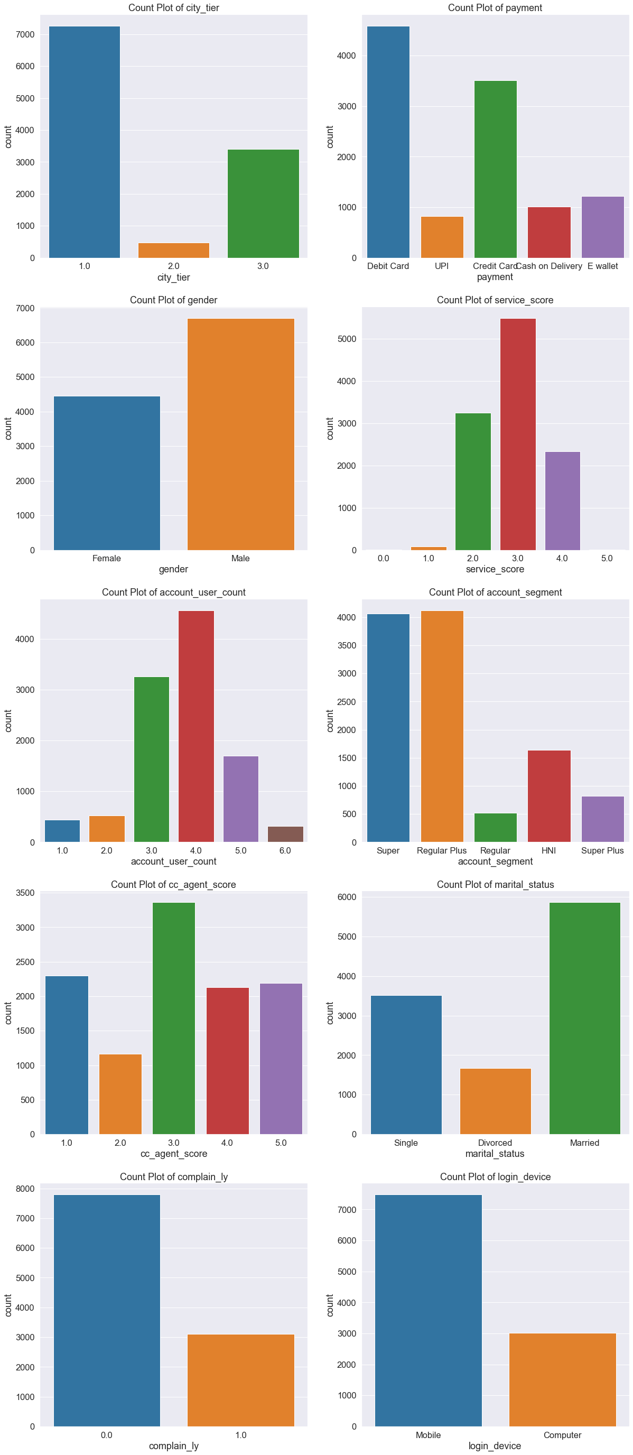





Figure 2. Count Plots for Categorical Features.

**Insights and Business Implications**

* **Highest** number of Customers from **Tier 1 city (65%).** The order of Cites according to decreasing number of customers is as below.

Tier 1 (65%) > Tier 3 (31%) > Tier 2 (4%)

* **Highest number** of Customers are preferring to **pay through debit cards**. The order of type of payment according to decreasing number of customers is as below.

Debit Card (41%) > Credit Card (31%) > E-Wallet (11%) > Cash on Delivery (9%) > UPI (7%)

* There is a greater number of male (60%) customers.

Male (60%) > Female (40%)

* Most of the customers have given service scores of 2, 3 and 4.
* Highest number of accounts have four mapped customers.
* **Highest** number of accounts belong **to super and regular plus segments**. The order of account segments according to decreasing number of customers is as below.

Regular Plus (37%) > Super (36%) > HNI (15%) > Super Plus (7%) > Regular (5%)

* **Highest** number of customers are **married** and **the lowest** number of customers **are divorced**. The order of marital status according to the decreasing number of customers is as below.

Married (53%) > Single (32%) > Divorced (15%)

* The number of customers who have **not given complaints (71%)** is **more than** the customers who **gave any complaints (29%)** in the last year.
* The number of customers **using mobile (71%)** is **more than** the number of customers **using computers (29%).**

**Bivariate Analysis**

**Count Plot of Categorical Features with Churn as Hue**

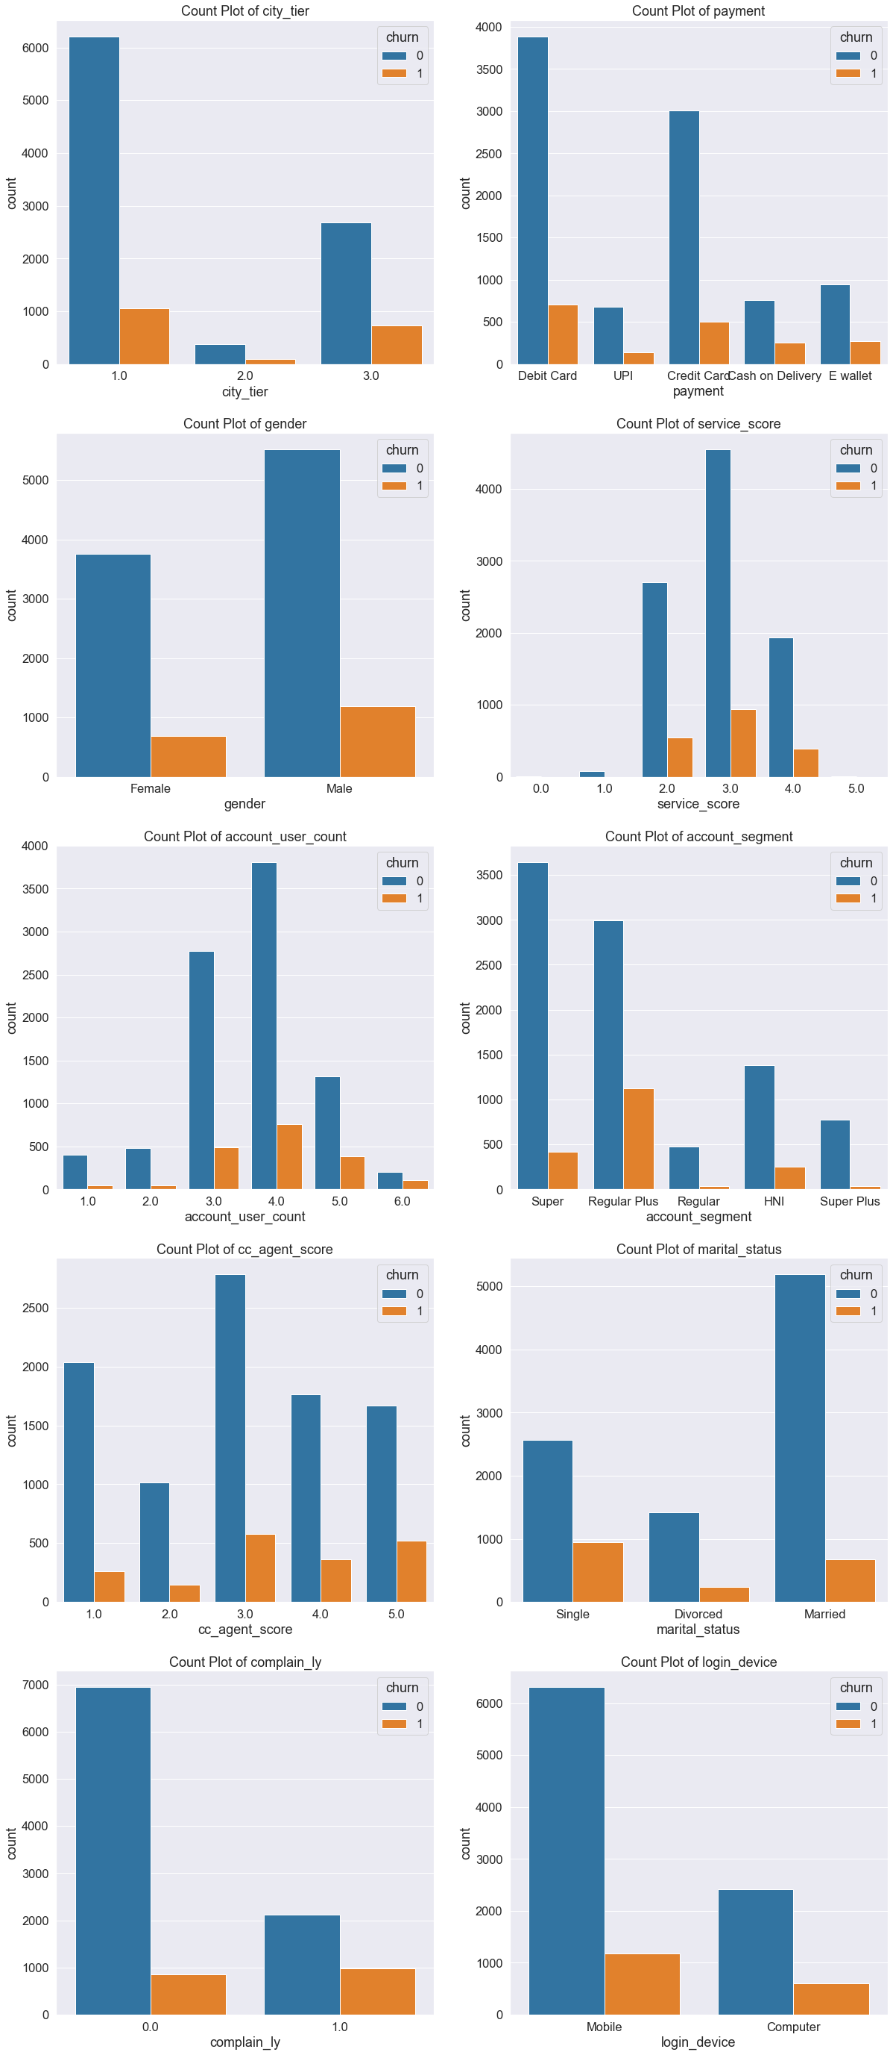



Figure 3. Count Plot of Categorical Features with Churn as Hue.

**Insights and Business Implications**

* Customers **from tier 3 cities are churning more** than those from other cities. The **decreasing order** of churn rate is as below.

Tier 3 (21.4%) > Tier 2 (20%) > Tier 1(14.5%)

* Customers paying through **cash on delivery are churning more** than those who prefer other payment methods. The decreasing order of churn rate is as below.

Cash on delivery (25%) > E-wallet (22.7%) > UPI (17.4%) > Debit card (15.3%) > Credit Card (14.2%)

* Male customers are slightly churning more than female customers.

Males (17.7%) > Females (15.5%)

* Customers who have given service scores like 2, 3 and 4 are churning. Other customers are not churning.
* Accounts mapped with 5 to 6 customers are churning more than other accounts.
* Customers from **regular plus and HNI segments are churning more** than those from other segments. The decreasing order of churn rate is as below.

Regular Plus (27.3%) > HNI (15.6%) > Super (10.2%) > Regular (7.7%) > Super Plus (4.9%)

* Customers who have given a high score to customer care agents are churning more than other customers.
* Customers who have **not married are churning more** than other customers. The decreasing order of churn rate is as below.

Single (26.9%) > Divorced (14.6%) > Married (11.5%)

* Customers who have **given complaints (31.8%) are churning more** than those who have not given any complaints (10.9%).
* Churn rate is slightly more in customers who are using a computer (19.8%) compared to mobile (15.7%).

**Bivariate Analysis for Numerical Features**

**Box Plot of Numerical Features with Churn as Hue**

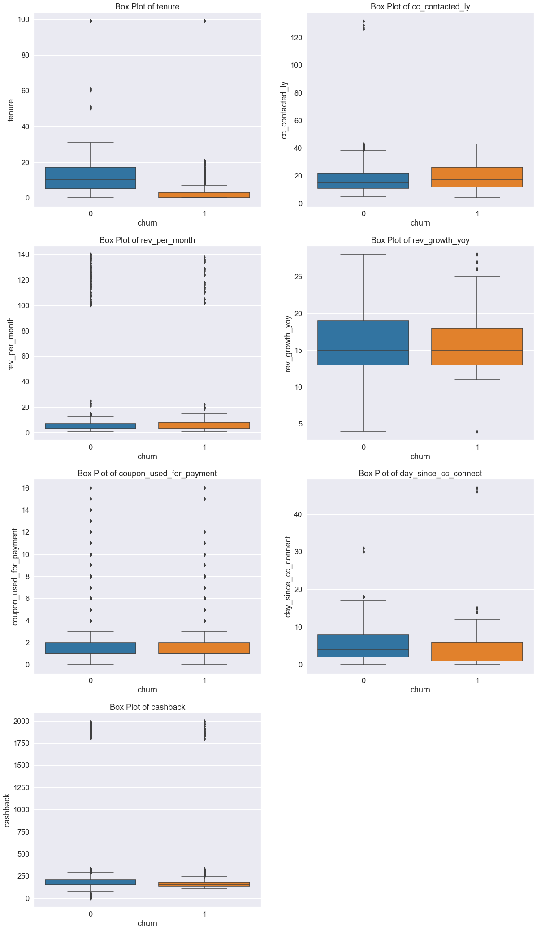



Figure 4. Box Plot of Numerical Features with Churn as Hue.

**Median Values of Numerical Features**

**Insights**

1. Median tenure of churning customers (1) is very much less than those who are not churning (10).
2. The median number of days since customers contacted is slightly less for churning customers (2) than for non-churning customers (4).
3. The median monthly cashback generated is slightly less for churning customers (152.7) than non-churning customers (168.3).
4. Other numerical features are influencing the target much.

|  |  |  |
| --- | --- | --- |
| Target / Feature | Not Churning | Churning |
| Tenure | 10 | 1 |
| CC Contacted LY | 15 | 17 |
| Revenue per Month | 5 | 5 |
| Revenue growth | 15 | 15 |
| Coupon used for Payment | 1 | 1 |
| Day since cc connect | 4 | 2 |
| Cashback | 168.3 | 152.7 |

**Pair Plot of Numerical Features**

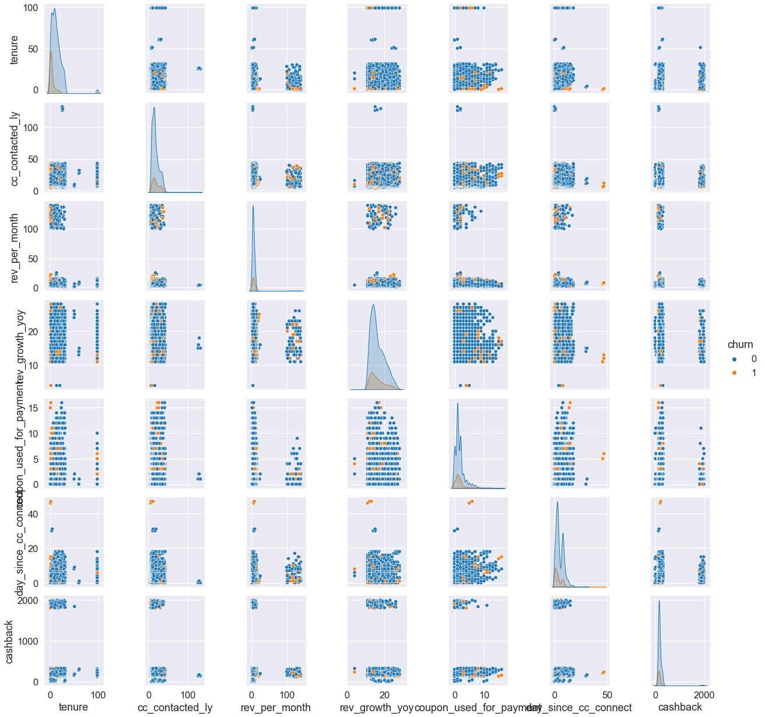

Figure 5. Pair Plot.

**Correlation Coefficients**

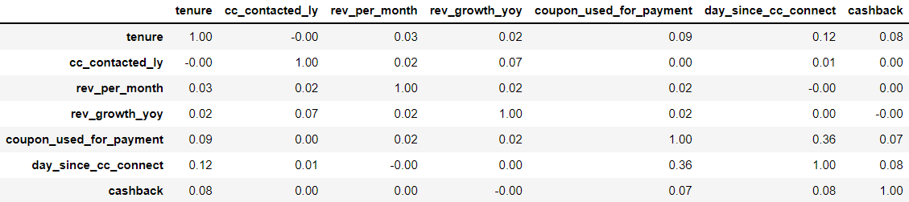

**Heat with Correlation Coefficients**

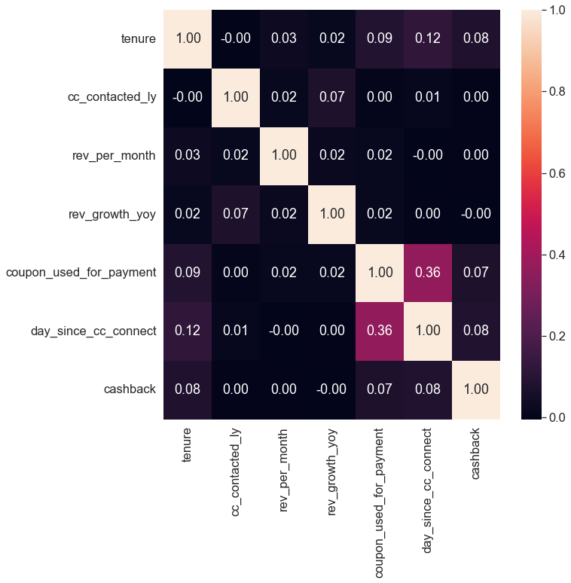

Figure 6. Heat Map with Correlation Coefficients.

**Note:** There are no significant correlations between the predictor variables.

**Multivariate Analysis**

**Churn across City Tier and Complain in last year**

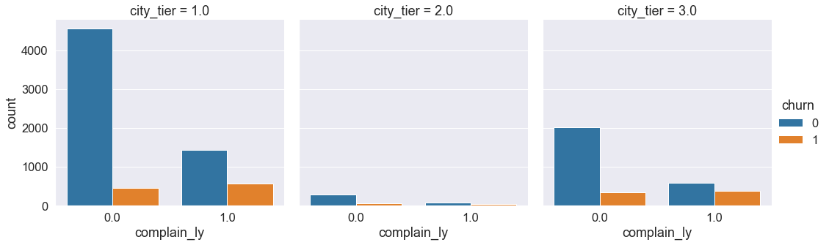

Figure 7. Churn across City Tier and Complain in last year

**Churn across Account Segment and Complain in last year**

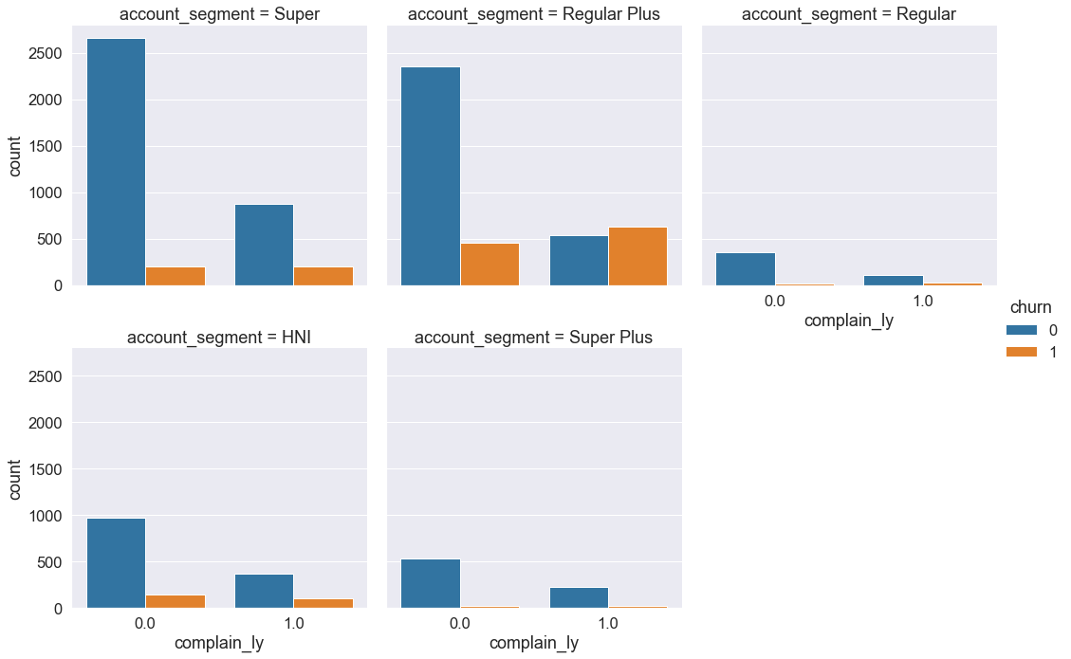

Figure 8. Churn across Account Segment and Complain in last year

**Churn across Account Segment and City Tier in last year**

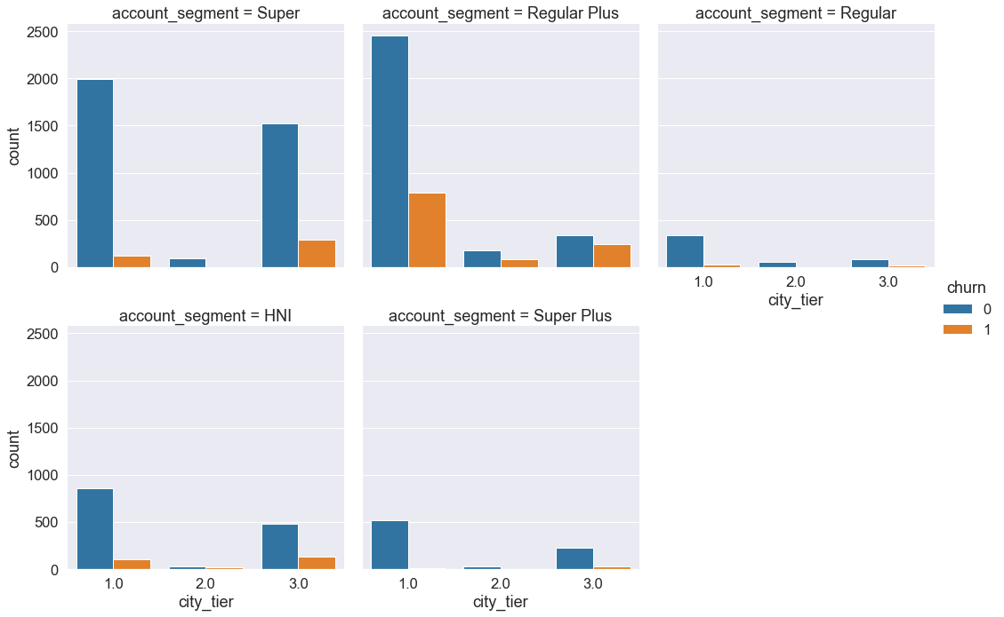

Figure 9. Churn across Account Segment and City Tier in last year

**Churn across Tenure and Day since cc connect**

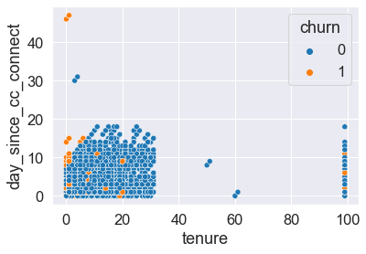

Figure 10. Churn across Day since cc connects and Tenure.

**Insights and Business Implications**

* Customers who have **given complaints are churning more** than those who have not given any complaints across all tiers of cities.
* Customers who have **given any complaints** are **churning maximum in tier 3 cities (39%)**. Customers who have **not given any complaints** are **churning maximum in tier 2 cities (15%)**.
* Customers who have **given complaints are churning more** than those who have not given any complaints across all segments of customers.
* Customers from the **regular plus segment are churning more** than those from other segments irrespective of whether they have given any complaints in the last year.

The churn rate of Regular Plus customers given any complaint (54%)

The churn rate of Regular Plus customers not given any complaint (16%)

* Customers **from tier 3 cities** **are churning more** than those from other cities across all segments of customers.
* Customers **from regular plus segments are churning more** than those from other segments across all tiers of cities.
* Customers with low tenure and contacted recently are churning more than those with high tenure and contacted customer care long before.

**Q3. Data Cleaning and Pre-Processing**

**Missing Value Treatment**

 

Table 6. Percentage of Null Values in Each Feature before and after Treating.

**Approach**

* If any record is **not having any value** for any feature. Then it is identified as **a null value**.
* As the **data has outliers**, the null values in **numerical features are imputed** with their respective **median values**.
* The null values in **categorical features are imputed** with their respective **mode values**.

**Outlier Treatment**

Let us check outliers visually by plotting box plots for each feature.

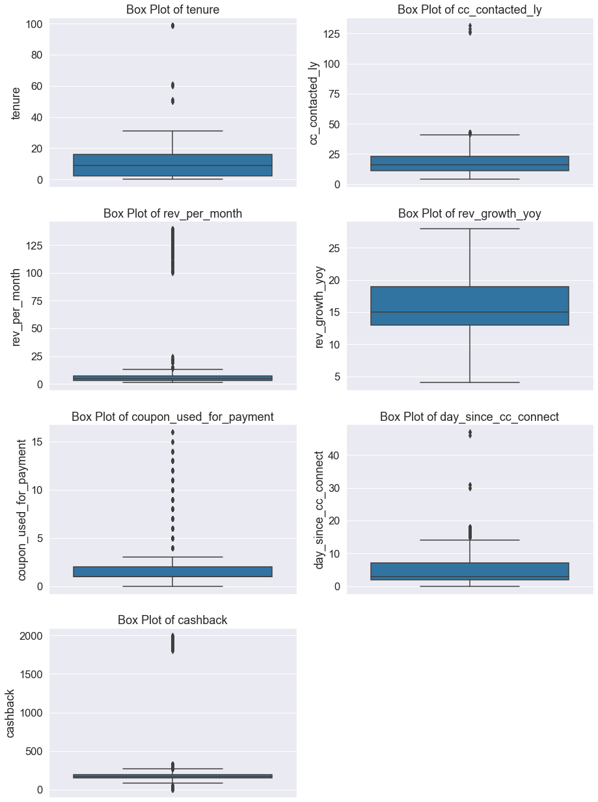



As we can see in the above box plots, outliers are present in almost all the features. Let us quantify it.

**Percentage of Outliers in Each Feature**

 

Table 7. Percentage of Outliers in Each Feature before and after Treating.

**Approach**

* The values which lie **outside the range [Q1-1.5*IQR, Q3+1.5*IQR]** are identified as outliers.
* The outliers in the above dataset are treated by the **capping** (replacing the values above the upper range with Q3+1.5*IQR) and **flooring** (replacing the values below the lower range with Q1-1.5*IQR) technique.

**Need for variable transformation (if any)**

All the features in the dataset **should have numerical values** before building any machine learning model. Hence, let us transform the categorical variables into numerical ones by following label encoding and one hot encoding techniques.

**Encoding of Categorical Data**

* There is one ordinal categorical variable i.e., account segment.
* There are four nominal categorical variables i.e., payment, gender, marital status and login device.
* Account segment ordinary variable is label encoded as per below order preference.

|  |  |
| --- | --- |
| **Sublevel in Account Segment** | **Label encoding** |
| Regular | 0 |
| Regular Plus | 1 |
| Super | 2 |
| Super Plus | 3 |
| HNI | 4 |

* Nominal categorical variables are encoded in a different way for **tree-based models (label encoding)** and **distance & weight-based models (one hot encoding – creating dummies).**

**Splitting the Dataset into Predictors and Target Sets**

* In the given dataset churn is the target variable, let us split the dataset into two parts.
* Except churn feature, all remaining features are taken in the predictor’s dataset.
* Churn feature is considered as the target variable.

**Distribution of Classes in Target Feature**

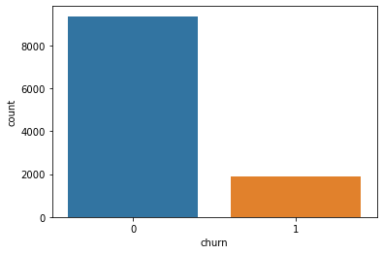

* The percentage of customers who are not churning is 83.2%
* The percentage of customers who are churning is 16.8%
* The data **is unbalanced** with the classes in the target feature but not so bad. As of now, we can proceed with the model building process.
* Later, if the performance of the model is not up to the mark, we can apply oversampling techniques such as SMOTE for the training dataset to improve the model performance.

**Splitting the Dataset into Train and Test Datasets**

* Let us split the predictor’s dataset and target dataset into train and test sets in the ratio of 70:30.

Table 8. Sample of the Train and Test Datasets for Tree-based Models.

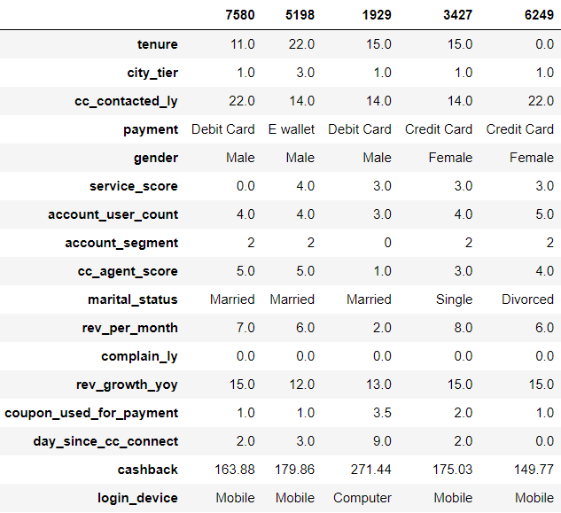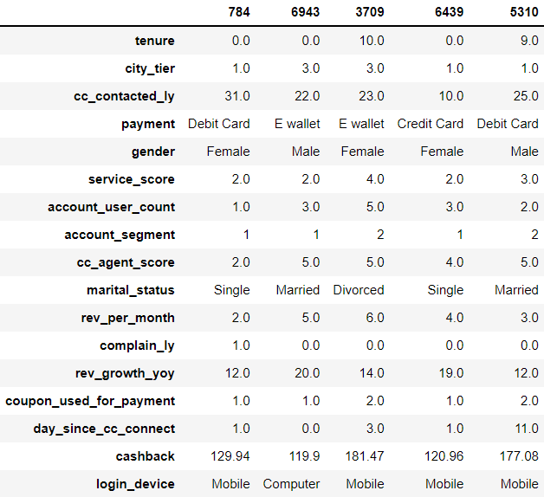

**Necessity of Scaling**

* Generally, Scaling improves the performance of **all distance-based models like Linear Discriminant Analysis and KNN** and **weight-based models like Artificial Neural Networks and Logistic Regression**. Even Scaling influences, the coefficients obtained for different features in the logistic regression model. By scaling, units can be avoided in coefficients and standardized coefficients are obtained. Also scaling improves the speed of convergence of the models.
* If we don’t scale the data, it gives higher weightage to features which have higher magnitude. Hence, it is always advisable to **bring all the features to the same scale** before proceeding to model building.
* In this dataset, the magnitudes of the statistical parameters like Mean, Standard Deviation, Minimum and Maximum are significantly different for all features (Refer below table). **Hence, scaling is required to bring all the features into a common scale before proceeding to model building.**
* Z-Score method is used to scale the data, i.e., finding the z-score value for each observation in the dataset by using the following formula.

Where, x = Value of the observation

µ = Mean

Sigma = Standard Deviation

* **Scaling is required for Logistic Regression, Linear Discriminant Analysis, Artificial Neural Networks, and KNN models.** The scaled dataset is used for these models.
* For other models like **Naive Bayes, Bagging, Random Forest, Ada Boosting, Gradient Boosting and Extreme Gradient Boosting** models, **scaling is not required**. Hence, the non-scaled dataset is used for these models.

Table 9. Mean and Standard Deviation of All Numeric Features.



**Sample of Scaled Datasets**

Predictor variables have been **scaled by using the z-score method**. Initially, the training dataset has been scaled by using its mean and standard deviation. Then test dataset has been **scaled by using train dataset parameters** (mean and standard deviation) **to avoid data leakage**.

Table 10. Samples of Train and Test Datasets after Scaling (for weight-based models).

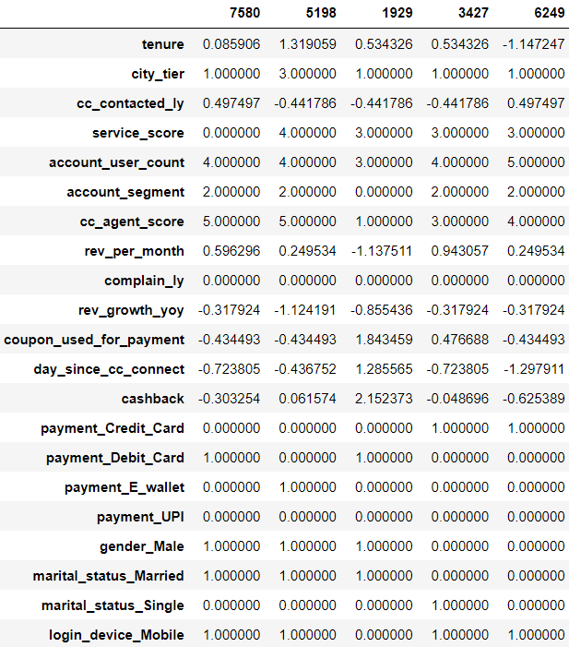 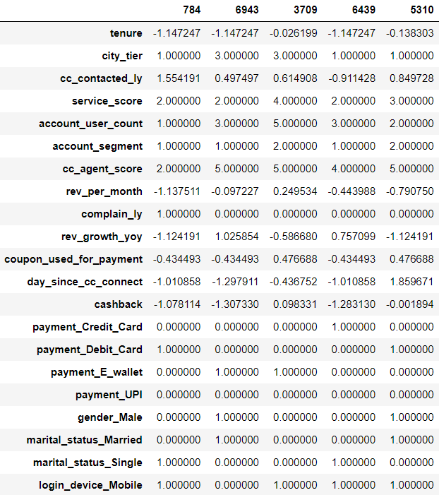

**Distribution of Target Variable Classes in Train and Test Datasets**

|  |  |  |  |
| --- | --- | --- | --- |
| **Class** | **Total Data** | **Training Data** | **Testing Data** |
| **Not Churn (0)** | 83.16% | 83.18% | 83.13% |
| **Churn (1)** | 16.84% | 16.82% | 16.87% |

**Note:**

* Churning customers are almost equally distributed in both training and testing datasets.

**Variables removed or added and why (if any)**

**Chi-Square Test**

* We have removed Account ID which is not required for the model building process.
* Let us **identify other insignificant variables** by performing **a chi-square test** for each categorical variable with the target variable.

Table 11. P-Values in chi-square test for each categorical variable.

|  |  |
| --- | --- |
| **Feature** | **P Values of Chi-Square Test** |
| City tier | 0 |
| Payment | 0 |
| Gender | 0.002502 |
| Service score | 0.002469 |
| Account user count | 0 |
| Account segment | 0 |
| cc agent score | 0 |
| Marital status | 0 |
| Complain ly | 0 |
| Login device | 0 |

As **p-value is less than 0.05 for all categorical features** in the chi-square test. Hence, all the categorical features are influencing the target variable **and they are important for model building**.

**Multicollinearity**

There is no significant correlation between the predictor variables. Anyway, let us check the multicollinearity by checking the Variance Inflation Factor values for each numerical feature.

* From the VIF table, it can be noticed that all features are having VIF of less than 5. Hence, there is **no significant multicollinearity between the variables**.
* Hence, it is **not required to drop any variable based on VIF** values.

|  |  |
| --- | --- |
| **Feature** | **VIF** |
| Cashback | 1.4 |
| Day since cc connect | 1.3 |
| Tenure | 1.3 |
| Coupons used for payment | 1.2 |
| Rev per month | 1.1 |

**Let us build the Logistic Regression model in the stats library to check the significance of the predictor variable in predicting the target**

The Regression model is built in the stats library by using a scaled dataset. The summary of the model is shown in the below table.

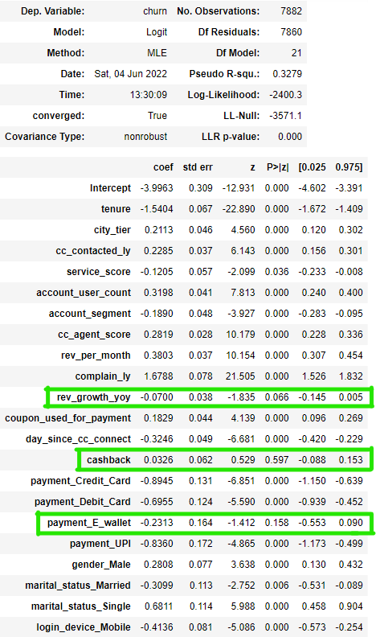

**Note:**

* Cashback, Revenue growth YOY and Payment through E-Wallet features have a p-value of more than 0.05. Hence, they are not significant.
* Anyway, these features are not dropped at this stage. Because these features may be important to predict the target in other models.
* Hence, let us review these features again after building other models also.

**Q4. Model building**

**Selection of Models**

* As we need to **predict the churn of the customers**, it is a **classification type supervised learning** problem. Let us build all classifier type machine learning models to predict the churn of the customers.
* Initially, **let us start with basic models** like Decision Trees, Artificial Neural Networks, and Logistic Regression with default hyperparameters **then we will build ensemble models** like Bagging, Random Forest, Ada Boosting, Gradient Boosting, and Extreme Gradient Boosting models with default hyperparameters.
* Various models are built with their respective default hyperparameters shown in the below table.

Table 12. Default Hyperparameters of All Models.

|  |  |
| --- | --- |
| **Model** | **Default Hyperparameter** |
| Decision Tree | Criterion = gini, Maximum depth = None |
| Random Forest | Number Estimators = 100, Criterion = gini,  Maximum Depth = None, Maximum Features = auto, Random State = 1 |
| Artificial Neural Networks | Number of Hidden Layers = 1, Number of Neurons = 100, Activation = relu, Solver = adam. |
| Logistic Regression | Penalty = 'l2', Tolerance = 0.0001, Random State = 1, Solver = lbfgs. |
| Linear Discriminant Analysis (LDA) | Solver = SVD, Tolerance = 0.0001 |
| k-nearest neighbours’ (KNN) | Number of neighbours = 5, Weights = uniform, Metric = Makowski |
| Bagging | Base Estimator = None, Number of Estimators = 10 |
| AdaBoosting | Base Estimator = None, Number of Estimators = 50, |
| Gradient Boosting | Number Estimators = 100, Maximum depth = 3, Random state = 1, Tolerance = 0.0001 |
| Extreme Gradient Boosting | Number Estimators = 100, Maximum depth = 6,  Random state = 1, Tolerance = 0.0001 |

**Evaluation of Models**

* After building various models with default hyperparameters, their **performance is evaluated** for both train and test datasets based on **True Positives, True Negatives, False Positives and False Negatives**.
* Performance metrics like **Accuracy, Recall, Precision and F1 score** are calculated for all the models to evaluate them.

**Performance Metrics of Models with Default Hyperparameters**

| **Model** | **True Positives** | | **True Negatives** | | **False Positives** | | **False Negatives** | |
| --- | --- | --- | --- | --- | --- | --- | --- | --- |
| **Train** | **Test** | **Train** | **Test** | **Train** | **Test** | **Train** | **Test** |
| Decision Tree | 1326 | 476 | 6556 | 2732 | 0 | 76 | 0 | 94 |
| Random Forest | 1326 | 478 | 6556 | 2797 | 0 | 11 | 0 | 92 |
| Artificial Neural Networks | 1203 | 453 | 6505 | 2748 | 51 | 60 | 123 | 117 |
| Logistic Regression | 600 | 258 | 6347 | 2719 | 209 | 89 | 726 | 312 |
| Linear Discriminant Analysis (LDA) | 561 | 250 | 6349 | 2715 | 207 | 93 | 765 | 320 |
| Naïve Bayes | 731 | 301 | 6090 | 2598 | 466 | 210 | 595 | 269 |
| KNN | 1207 | 473 | 6515 | 2772 | 41 | 36 | 119 | 97 |
| Bagging | 1309 | 457 | 6553 | 2779 | 3 | 29 | 17 | 113 |
| AdaBoosting | 754 | 322 | 6314 | 2709 | 242 | 99 | 572 | 248 |
| Gradient Boosting | 844 | 345 | 6385 | 2739 | 171 | 69 | 482 | 225 |
| Extreme Gradient Boosting | 1323 | 482 | 6556 | 2779 | 0 | 29 | 3 | 88 |

Table 13. Performance Metrics of Models with Default Hyperparameters.

|  |  |  |  |  |  |  |  |  |  |  |
| --- | --- | --- | --- | --- | --- | --- | --- | --- | --- | --- |
| **Metric/Model** | **Accuracy** | | **ROC-AUC** | | **Precision** | | **Recall** | | **F1 Score** | |
| **Train** | **Test** | **Train** | **Test** | **Train** | **Test** | **Train** | **Test** | **Train** | **Test** |
| Decision Tree | 1 | 0.95 | 1 | 0.9 | 1 | 0.86 | 1 | 0.84 | 1 | 0.85 |
| Random Forest | 1 | 0.97 | 1 | 0.99 | 1 | 0.98 | 1 | 0.84 | 1 | 0.9 |
| ANN | 0.98 | 0.95 | 0.99 | 0.97 | 0.96 | 0.88 | 0.91 | 0.79 | 0.93 | 0.84 |
| Logistic Regression | 0.88 | 0.88 | 0.87 | 0.86 | 0.74 | 0.74 | 0.45 | 0.45 | 0.56 | 0.56 |
| LDA | 0.88 | 0.88 | 0.86 | 0.85 | 0.73 | 0.73 | 0.42 | 0.44 | 0.54 | 0.55 |
| Naive Bayes | 0.87 | 0.86 | 0.82 | 0.81 | 0.61 | 0.59 | 0.55 | 0.53 | 0.58 | 0.56 |
| KNN | 0.98 | 0.96 | 1 | 0.98 | 0.97 | 0.93 | 0.91 | 0.83 | 0.94 | 0.88 |
| Bagging | 1 | 0.96 | 1 | 0.98 | 1 | 0.94 | 0.99 | 0.8 | 0.99 | 0.87 |
| AdaBoosting | 0.9 | 0.9 | 0.91 | 0.91 | 0.76 | 0.76 | 0.57 | 0.56 | 0.65 | 0.65 |
| Gradient Boosting | 0.92 | 0.91 | 0.95 | 0.93 | 0.83 | 0.83 | 0.64 | 0.61 | 0.72 | 0.7 |
| Extreme Gradient Boosting | 1 | 0.97 | 1 | 0.99 | 1 | 0.94 | 1 | 0.85 | 1 | 0.89 |

* From the above metrics table, we can notice that a few models **like Decision Tree, Random Forest, ANN, Bagging and Extreme Gradient Boosting models are overfitted slightly.** Let us **tune the hyperparameters** of these models to eliminate overfitting.
* Apart from that **class level metrics like recall, precision and F1 score are low**.
* Hyperparameters of all models are tuned **to eliminate overfitting and to improve metrics**.

**Efforts to improve model performance**

* The models discussed in the above section are **tuned with optimum hyperparameters by using GridsearchCV** to eliminate overfitting and to improve the performance of the model.
* The tuned hyperparameters for each model are listed in the below table.
* **The models are rebuilt by using below-tuned hyperparameters**.

Table 14. Tuned Hyperparameters of All Models.

|  |  |
| --- | --- |
| **Model** | **Tuned Hyperparameter** |
| Decision Tree | Maximum depth = 14 |
| Random Forest | Number of Estimators: 201, Maximum Features: 9  Maximum Depth: 16 |
| Artificial Neural Networks | Number of Neurons: 350 |
| Logistic Regression | Solver: newton-CG |
| Linear Discriminant Analysis (LDA) | Solver: svd |
| Bagging | Number of Estimators: 25 |
| AdaBoosting | Number of Estimators: 151 |
| Gradient Boosting | Number of Estimators: 351  Maximum Depth: 10 |
| Extreme Gradient Boosting | Maximum Depth: 9  Number of Estimators: 201 |

**Q5. Model validation**

**Performance Metrics of Models with Tuned Hyperparameters**

| **Model** | **True Positives** | | **True Negatives** | | **False Positives** | | **False Negatives** | |
| --- | --- | --- | --- | --- | --- | --- | --- | --- |
| **Train** | **Test** | **Train** | **Test** | **Train** | **Test** | **Train** | **Test** |
| Decision Tree | 1292 | 467 | 6543 | 2726 | 13 | 82 | 34 | 103 |
| Random Forest | 1325 | 487 | 6556 | 2791 | 0 | 17 | 1 | 83 |
| Artificial Neural Networks | 1321 | 516 | 6555 | 2772 | 1 | 36 | 5 | 54 |
| Logistic Regression | 600 | 258 | 6346 | 2719 | 210 | 89 | 726 | 312 |
| Linear Discriminant Analysis (LDA) | 561 | 250 | 6349 | 2715 | 207 | 93 | 765 | 320 |
| Naïve Bayes | 731 | 301 | 6090 | 2598 | 466 | 210 | 595 | 269 |
| KNN | 1207 | 473 | 6515 | 2772 | 41 | 36 | 119 | 97 |
| Bagging | 1326 | 489 | 6555 | 2777 | 1 | 31 | 0 | 81 |
| AdaBoosting | 776 | 332 | 6317 | 2697 | 239 | 111 | 550 | 238 |
| Gradient Boosting | 1326 | 512 | 6556 | 2795 | 0 | 13 | 0 | 58 |
| Extreme Gradient Boosting | 1326 | 499 | 6556 | 2785 | 0 | 23 | 0 | 71 |

Table 15. Performance Metrics of Models with Tuned Hyperparameters.

|  |  |  |  |  |  |  |  |  |  |  |
| --- | --- | --- | --- | --- | --- | --- | --- | --- | --- | --- |
| **Metric/Model** | **Accuracy** | | **ROC-AUC** | | **Precision** | | **Recall** | | **F1 Score** | |
| **Train** | **Test** | **Train** | **Test** | **Train** | **Test** | **Train** | **Test** | **Train** | **Test** |
| Decision Tree | 0.99 | 0.95 | 1 | 0.91 | 0.99 | 0.85 | 0.97 | 0.82 | 0.98 | 0.83 |
| Random Forest | 1 | 0.97 | 1 | 0.99 | 1 | 0.97 | 1 | 0.85 | 1 | 0.91 |
| ANN | 1 | 0.97 | 1 | 0.99 | 1 | 0.93 | 1 | 0.91 | 1 | 0.92 |
| Logistic Regression | 0.88 | 0.88 | 0.87 | 0.86 | 0.74 | 0.74 | 0.45 | 0.45 | 0.56 | 0.56 |
| LDA | 0.88 | 0.88 | 0.86 | 0.85 | 0.73 | 0.73 | 0.42 | 0.44 | 0.54 | 0.55 |
| Naive Bayes | 0.87 | 0.86 | 0.82 | 0.81 | 0.61 | 0.59 | 0.55 | 0.53 | 0.58 | 0.56 |
| KNN | 0.98 | 0.96 | 1 | 0.98 | 0.97 | 0.93 | 0.91 | 0.83 | 0.94 | 0.88 |
| Bagging | 1 | 0.97 | 1 | 0.98 | 1 | 0.94 | 1 | 0.86 | 1 | 0.9 |
| AdaBoosting | 0.9 | 0.9 | 0.92 | 0.91 | 0.76 | 0.75 | 0.59 | 0.58 | 0.66 | 0.66 |
| Gradient Boosting | 1 | 0.98 | 1 | 0.99 | 1 | 0.98 | 1 | 0.9 | 1 | 0.94 |
| Extreme Gradient Boosting | 1 | 0.97 | 1 | 0.99 | 1 | 0.96 | 1 | 0.88 | 1 | 0.91 |

* From the above table, we can notice that **the accuracy of the test dataset is slightly less than the accuracy of the training dataset for almost all the models**. Hence, we can conclude that **overfitting is reduced for all models except for the Decision Tree model**.
* Let us compare the performance metrics of all the models obtained for the test dataset to find out the most optimized model (Best Model).

**Comparison of Models and Selecting the Best Model**

* As there is a **class imbalance in the target variable**, it is **not recommended to rely on only accuracy**. We should **refer to class-level metrics like recall, precision and F1 score**.
* In this project, the **best model** is selected based on the **recall metric**. The **best model** should have **a high recall**. It means the model should **predict almost all the customers who are about churn as churning** customers. Hence, the company can **try to retain those customers** by providing customer-specific offers.

Table 16. Performance Metrics of all Models with Tuned Hyperparameters for the Test Dataset.

|  |  |  |  |  |  |
| --- | --- | --- | --- | --- | --- |
| **Model/Metric** | **Accuracy** | **ROC-AUC** | **Precision** | **Recall** | **F1 Score** |
| Decision Tree | 0.95 | 0.91 | 0.85 | 0.82 | 0.83 |
| Random Forest | 0.97 | 0.99 | 0.97 | 0.85 | 0.91 |
| ANN | 0.97 | 0.99 | 0.93 | 0.91 | 0.92 |
| Logistic Regression | 0.88 | 0.86 | 0.74 | 0.45 | 0.56 |
| LDA | 0.88 | 0.85 | 0.73 | 0.44 | 0.55 |
| Naive Bayes | 0.86 | 0.81 | 0.59 | 0.53 | 0.56 |
| KNN | 0.96 | 0.98 | 0.93 | 0.83 | 0.88 |
| Bagging | 0.97 | 0.98 | 0.94 | 0.86 | 0.9 |
| AdaBoosting | 0.9 | 0.91 | 0.75 | 0.58 | 0.66 |
| Gradient Boosting | 0.98 | 0.99 | 0.98 | 0.9 | 0.94 |
| Extreme Gradient Boosting | 0.97 | 0.99 | 0.96 | 0.88 | 0.91 |

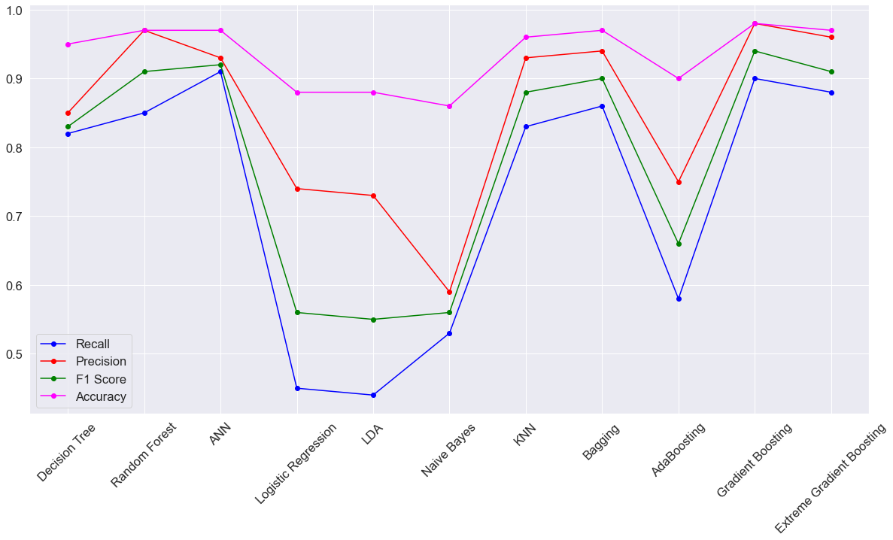

Figure 11. Performance Metrics of all Models with Tuned Hyperparameters for the Test Dataset.

* From the above plot, we can notice that **the recall is less than the precision for most of the models**. But in churn prediction problems**, recall (having low false negatives) for the minority class is more important than precision (having low false positives),** because retaining customers by providing customer-specific offers involves less cost than attracting new customers.
* Hence, it is **very important to predict all the customers who are on the verge of churning accurately**. In this process, even if a few customers who are not likely to churn are predicted as churned is acceptable.
* As we have more gap between the precision and recall for most of the models, let us **try to improve the recall at the expense of precision without affecting the F1 Score much by changing the threshold value to 0.4 instead of 0.5** (default threshold).

Table 17. Performance Metrics of all Models with a threshold of 0.4 for the Test Dataset.

| **Model/Metric** | **Accuracy** | **ROC-AUC** | **Precision** | **Recall** | **F1 Score** |
| --- | --- | --- | --- | --- | --- |
| Decision Tree | 0.95 | 0.91 | 0.85 | 0.82 | 0.83 |
| Random Forest | 0.97 | 0.99 | 0.92 | 0.9 | 0.91 |
| ANN | 0.97 | 0.99 | 0.92 | 0.92 | 0.92 |
| Logistic Regression | 0.88 | 0.86 | 0.66 | 0.55 | 0.6 |
| LDA | 0.88 | 0.85 | 0.63 | 0.52 | 0.57 |
| Naive Bayes | 0.86 | 0.81 | 0.51 | 0.62 | 0.56 |
| KNN | 0.96 | 0.98 | 0.93 | 0.83 | 0.88 |
| Bagging | 0.97 | 0.98 | 0.9 | 0.89 | 0.89 |
| AdaBoosting | 0.9 | 0.91 | 0.17 | 1 | 0.29 |
| Gradient Boosting | 0.98 | 0.99 | 0.97 | 0.9 | 0.94 |
| Extreme Gradient Boosting | 0.98 | 0.99 | 0.97 | 0.92 | 0.94 |

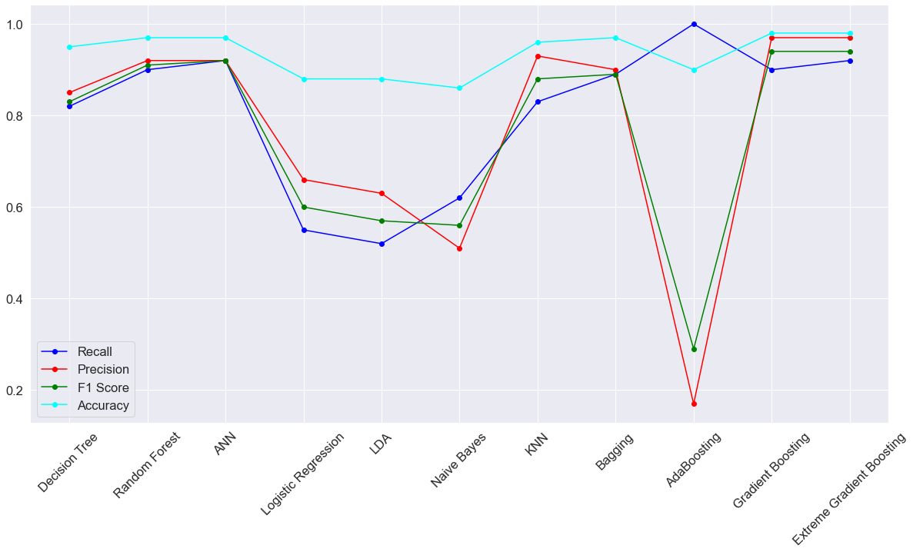

Figure 12. Performance Metrics of all Models with Tuned Hyperparameters and threshold of 0.4 for the Test Dataset.

From the above table and plot, we can derive the below inferences.

* Extreme Gradient Boosting (F1 Score = 0.94), Gradient Boosting (F1 Score = 0.94), Artificial Neural Networks (F1 Score = 0.92), and Random Forest models (F1 Score = 0.91) are the **most optimized models based their F1 scores**.
* As class-level performance metrics like Precision, Recall, and F1 **Score are very much near to the above four models**, we can select any one model from the above four models as the best **model based on interpretation requirements by business and computational power**.
* As Extreme Gradient Boosting Model (Precision = 0.97, Recall = 0.92, F1 Score = 0.94) is performing **slightly better than the remaining three models**, let us consider **the Extreme Gradient Boosting Model as the best model for predicting churn**.

**Q6. Final interpretation / recommendation**

**Interpretation of the Extreme Gradient Boosting (XGB) Model**

* As the recall is 0.92, this model may miss 8 customers who are likely to churn out of 100 customers. **Those 8 customers are predicted as not churn by the model**. The DTH company may not provide any customer-specific offers to these 8 customers and these customers may churn over time. **The business has to spend more money to attract new customers in place of the churned customers.**
* As the precision is 0.97, this model **may add 3 customers who are not likely to churn out of 100 customers to the churning customers’ list.** **Those 3 customers are predicted to churn by the model but actually, they are not likely to churn.** The DTH company may provide customer-specific offers to these 3 customers also along with the remaining 97 customers. This is a loss to the business. **Unnecessarily business is spending on these three customers to retain them even though they are not likely to churn.** Anyway, it is only for three customers, it would be less amount only.

**Feature Importance**

* According to XGB Model, **Tenure, any complaints received in the last 12 months, account segment, city tier, and customer care agent score are the five most important features** for predicting the churn.

|  |  |
| --- | --- |
| **Feature** | **IMP** |
| Tenure | 0.2 |
| Complain Last Year | 0.18 |
| City Tier | 0.08 |
| Account Segment | 0.07 |
| CC Agent Score | 0.07 |
| Day since CC Connect | 0.06 |
| Payment | 0.06 |
| Login Device | 0.06 |
| Marital Status | 0.05 |
| Gender | 0.05 |

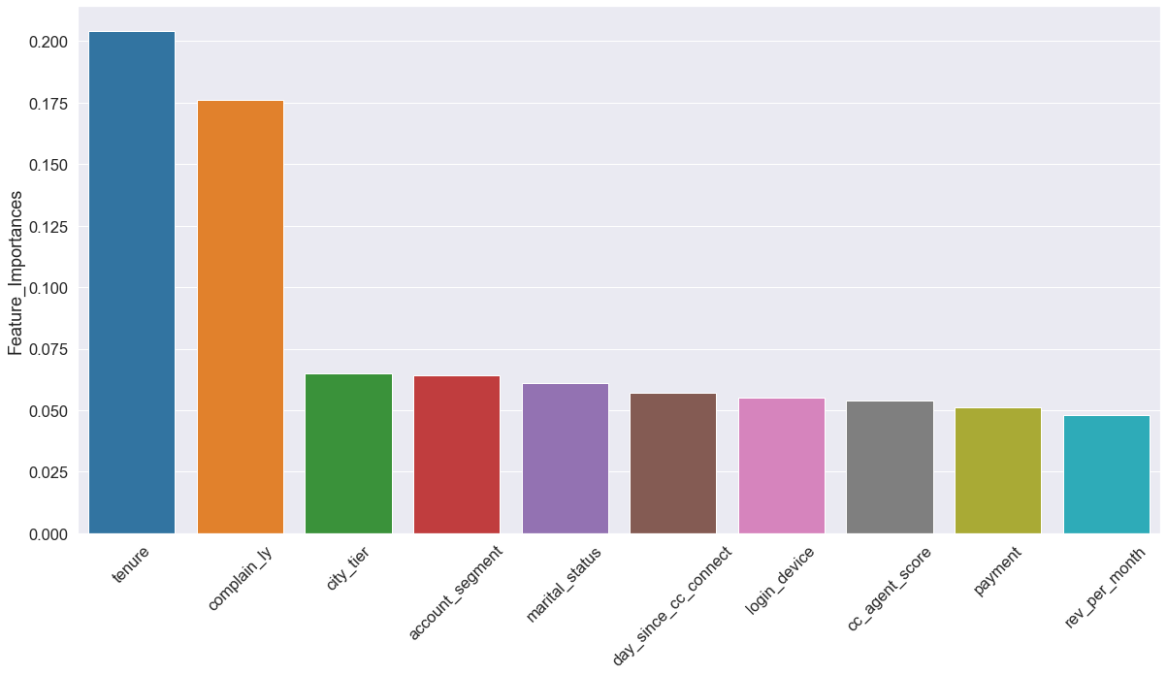

Figure 13. Features Importance of Top 10 Features in Extreme Gradient Boosting Model.

**Recommendations**

The following are the recommendations given to the DTH company.

* **Extreme Gradient Boosting model** can be used for churn prediction.
* 75th percentile of tenure of churned customers is less than the 25th percentile of tenure of not-churned customers. Hence, there is clear evidence that most of the **churned customers may be newly added customers**.
* **Newly joined customers** **should be given some offers** to reduce the churn rate.

|  |  |  |
| --- | --- | --- |
| **Measure** | **Tenure** | |
| **Not Churning** | **Churning** |
| Mean | 12.4 | 4.3 |
| Standard Deviation | 12.6 | 12.1 |
| Minimum | 0 | 0 |
| Q1 | 5 | 0 |
| Median | 10 | 1 |
| Q3 | 17 | 3 |
| Maximum | 99 | 99 |

* Almost 32% of customers who raised any complaints in the last 12 months are churning. **It means most of the customers are not satisfied with the way complaints are resolved**. The Business should take some measurable actions on the **complaints resolution system.**

|  |  |  |
| --- | --- | --- |
| **Any Complaints/Churn** | **No** | **Yes** |
| Not Churning | 89% | 68% |
| Churning | 11% | 32% |

* Customers from **tier 3 cities (21.4%) are churning more** than those from other cities.
* The company may review the customers who are residing in **tier 3 cities to attract them with suitable offers to retain** them for a long time.

|  |  |  |
| --- | --- | --- |
| **Churn/City Tier** | **Not Churning** | **Churning** |
| Tier 1 | 85.5% | 14.5% |
| Tier 2 | 80.0% | 20.0% |
| Tier 3 | 78.6% | 21.4% |

* Customers from the **regular plus (27.3%) segment** are churning more than those from other segments.
* The company may think about this segment of customers **to provide customer-specific offers** to retain them for a long time.

|  |  |  |
| --- | --- | --- |
| **Churn/Account Segment** | **Not Churning** | **Churning** |
| HNI | 84.4% | 15.6% |
| Regular | 92.3% | 7.7% |
| Regular Plus | 72.7% | 27.3% |
| Super | 89.8% | 10.2% |
| Super Plus | 95.1% | 4.9% |

|  |  |  |  |  |  |
| --- | --- | --- | --- | --- | --- |
| **Payment/Churn** | Cash on Delivery | Credit Card | Debit Card | E-Wallet | UPI |
| **Not Churning** | 75 | 85.8 | 84.7 | 77.3 | 82.6 |
| **Churning** | 25 | 14.2 | 15.3 | 22.7 | 17.4 |

* Customers who are paying through **cash on delivery (25%)** **and E-wallet (22.7%) are churning** more than other customers.
* Customers may not be getting any discounts and offers if they pay through cash on delivery and E-wallet.
* The Company can review these payment options and **add a few discounts to these payment options**.
* **Churning customers** contacted customer care **recently** than not churning customers.
* Customers might be **churning if they are not satisfied** with the support provided by customer care.
* The Business should focus on improving the **customer care support system.**

|  |  |  |
| --- | --- | --- |
| **Measure** | **Day Since CC Connect** | |
| **Not Churning** | **Churning** |
| Mean | 5 | 3 |
| Standard Deviation | 4 | 4 |
| Minimum | 0 | 0 |
| Q1 | 2 | 1 |
| Median | 4 | 2 |
| Q3 | 8 | 6 |
| Maximum | 31 | 47 |